

Name: Krishnaraj Prashant Thadesar. Class: F.Y B.Tech Division 9. Batch: I3.

Roll No.: 109054 Expt. No. 5 .

Performed on: 24/09/21 . Submitted on: 10/10/21 . Teacher’s Sign.: .

**STUDY OF CURVILINEAR MOTION**

*Purpose of the experiment:*

To demonstrate and study the curvilinear motion of a particle. To study the expression for position, velocity and acceleration of a particle using different frames of references. To develop the differential equations of curvilinear motion using Newton's second law.

*Instruments:*

Smooth sphere, circular rim with smooth surface, meter scale, string, saw dust.

*Theory:*

*Expressions of Curvilinear Motion:*

When a moving particle describes a curved path, it is said to have *curvilinear motion*. When the path of the particle is lying in one plane, then the motion is *a two-dimensional motion (plane motion).* When the path of the particle is not lying in one plane then it is, *a three-dimensional motion (space motion).*

There are 3 different ways to express the position, velocity and acceleration of a particle subjected to curvilinear translation along a plane curve.

These are as under:

1. *Using Cartesian frame of reference i.e., rectangular coordinates:*
   1. Coordinates of a point: x, y (functions of time)
   2. Position Vector: $\vec{r}=x\hat{i}+y\hat{j}$
   3. Velocity Vector: $\vec{v}=x^{'}\hat{i}+y^{'}\hat{j}= v_{x}\hat{i}+v_{y}\hat{y}$
   4. Acceleration Vector: $a=x^{''}\hat{i}+y^{''}\hat{j}-m∕s$
2. *Using Polar frame of reference i.e., polar coordinates:*
   1. Coordinates of a point: $r, θ$ (Functions of time)
   2. Position Vector: $\vec{r}=r⋅{\hat{e}}_{r}$ (m)
   3. Velocity Vector: $\vec{v}=r^{'}⋅{\hat{e}}_{r}rt+ θ^{'}{\hat{e}}_{θ}$ (m/s­)
   4. Acceleration Vector:(m/s­2)
3. *Using Path Variables:*
   1. Velocity Vector: $\vec{v}=ν⋅{\hat{e}}_{t}$
   2. Acceleration Vector: $a=\left(\frac{ⅆv}{ⅆt}\right){\hat{e}}_{t}+\left(\frac{v^{2}}{ρ}\right){\hat{e}}_{n}$



*Differential equations of curvilinear motion:*

If the resultant force acting on the particle varies in the direction as well as in the  
magnitude, the particle is subjected to curvilinear motion. In this case we can  
resolve the force acting on the particle along any two mutually perpendicular  
directions and we can write the differential equations of curvilinear motion using Newton’s second law of motion.

1. Using Cartesian frame of reference
$$∑F_{x}=m⋅a_{x}=m⋅x^{''} and ∑F_{y}=m⋅a_{y}=my^{''}$$

2. Using polar frame of reference
$$∑F_{r}=m⋅a_{r}=m\left(r^{''}-r{θ^{'}}^{2}\right) and ∑f_{θ}=m⋅a_{θ}=m\left(rθ^{''}+2r^{'}θ^{'}\right)$$

3. Using path variables:

$$∑f_{t}=ma_{t}=m⋅\frac{ⅆv}{ⅆt} and ∑F_{n}=m⋅a_{n}=\frac{mv^{2}}{ρ}$$

Referring to fig. 1, if a small smooth sphere of mass ***‘m’*** starts from rest at ***A*** (the top of a frictionless circular rim) and slides in a vertical plane along the *arc AB,* the sliding sphere leaves the circular path at B when it makes an angle ***Ф = 48.190*** at the center. After point ***B***, the sphere travels along trajectory ***BC*** and strikes the horizontal plane ***CD*** at point ***C***. The distance of point ***C***, from the bottom of the rim is ***(1.46) r***. *Here, the motion of the sphere from* ***A to C*** *is a curvilinear motion.*

But for the path ***AB***, the radius is constant, hence the motion of the sphere from ***A to B*** is circular motion. For the path ***BC***, the only force acting on the spherical particle is its weight. *Hence the motion of the particle form* ***B to C*** *is a projectile motion.*

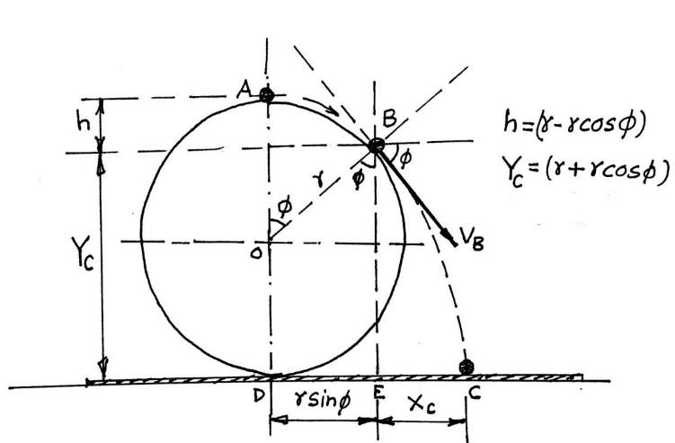

*Fig. 1: curvilinear motion of the particle*



For the circular motion of the particle from A to B:  
applying Work-Energy principle,

*(Work-done in travelling from A to B) = (Change in kinetic energy from A to B)*

$$m\left(-g\right)\left[-h\right]=\frac{1}{2}mV_{B}^{2}-\frac{1}{2}mV_{A}^{2}$$

$$but, h=\left(r-r\cos{∅}\right) and V_{A}=0$$

$V_{B}^{2}=2g⋅r\left(1-\cos{∅}\right)$*….(1)*

Consider the free body diagram of the particle at position B, (Ref. Fig. 2) Applying Newton’s second law of motion in the normal direction we get

$$∑F_{n}=m⋅a_{n}$$

$$m{g\cos{∅}}=\frac{mV_{B}^{2}}{r}$$

$V_{B}^{2}=r⋅\cos{ϕ}⋅g$….(2)

Equating equations (1) and (2) We get

$$V_{B}^{2}=2gr\left(1-\cos{ϕ}\right)=gr\cos{ϕ}$$

$$Therefore, \cos{ϕ}=0.66$$

$$\cos{ϕ}=2/3$$

$$ϕ=48⋅{19}^{0}$$

$$V_{B}^{2}=\left(r\right)\left(9.81\right)\cos\left({48.19}^{0}\right)=2⋅557\sqrt{r}$$

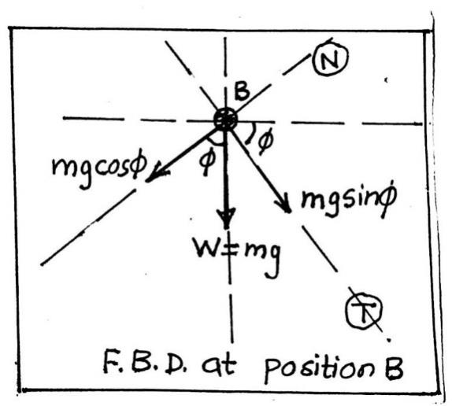

*Fig. 2: FBD of particle at B*



For the projectile motion of the particle from B to C:  
Consider the origin of the frame of reference as point B (Ref. Fig. 3). .

$-Y_{C}=-\left(V_{B}\sin{ϕ}\right)t-\frac{1}{2}gt^{2}$ ${so, Y}_{C}=\left(V_{B}\sin{ϕ}\right)t+\frac{1}{2}gt^{2}$

$$r+r\cos{ϕ}=\left(v_{B}\sin{ϕ}\right)t+\frac{1}{2}gt^{2}, or \left(4⋅905\right)t^{2}+1⋅906\left(\sqrt{r}\right)t-\left(1⋅667\right)r=0$$

$$t=\left(0⋅42\right)\sqrt{r}…(3)$$

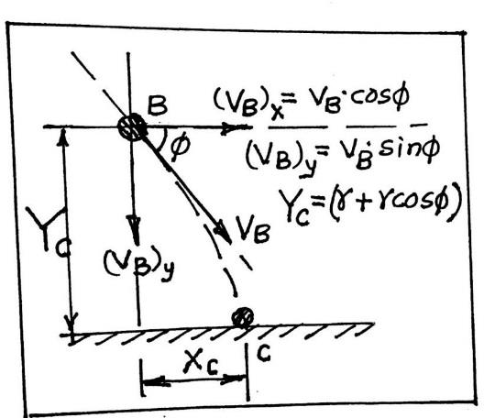

*Fig. 3: Projectile motion of the particle*

For the horizontal motion from B to C

$$x_{C}=\left(v_{B}\cos{ϕ}\right)t$$

$$\left(2⋅56\right)\sqrt{r}\left(\cos{{48.19}^{0}}\right)\left(0⋅42\right)\sqrt{r}=\left(0⋅72\right)r$$

Therefore, distance

$$CD=ED+EC=r\sin{ϕ}+X_{C}$$

$$= r\sin\left(48⋅{19}^{0}\right)+\left(0.72\right)r=\left(1⋅46\right)r=C$$

*Procedure:*

1. Measure the radius of the rim.
2. Arrange the circular rim to rest in vertical position at the support.
3. Spread the saw dust on the table where the steel ball is likely to strike.
4. Place the smooth steel ball on the highest point A on the rim and allow it to roll along the groove.
5. Locate the point on the rim where the ball loses its contact with the rim i.e., locate point B by visual observation.
6. Locate the point on the table where the ball strikes the horizontal plane i.e., locate point C.
7. With the help of a thread, measure the arc length AB along the rim and also measure the distance CD on the table.
8. Determine by using the relation arc length AB - r. (where is in Radians). Convert to degrees.
9. Verify ***Ф*** = 48.19° and CD = (1.46) r.

*Observations and calculation:*

1. Radius of the rim r = 0.31m
2. Arc length AB = 0.28m
3. Distance CD = 0.45 m
4. We know,

$$s=r⋅θ$$

So,

$$0.28=\left(0.31\right)θ$$

$$=0.{9032}^{C}$$

$$θ=51.{75}^{0}$$

The Experimental Value will be:

$$\left(\frac{CD}{r}\right)=\left(\frac{0.45}{0.31}\right)=1.4516$$

*Results:*

|  |  |  |
| --- | --- | --- |
|  | Analytical value | Experimental value |
| ***Ф*** | 48.19 | 51.75 |
| CD | (1.46) | 1.45 r |

*Conclusion:*

Thus, we have successfully studied the expression for curvilinear motion of a particle through multiple frames of references.

*Questions: -*

1. What are the different frames of references used in curvilinear motion?
   1. Frames of reference, are mainly of two types:
      1. Inertial Frame of Reference: An inertial frame of reference is a frame where Newton’s law holds true. That means if no external force is acting on a body it will stay at rest or remain in [uniform motion](https://byjus.com/physics/uniform-motion-and-non-uniform-motion/).
      2. Non-inertial Frame of Reference: A non-inertial reference frame is a [frame of reference](https://en.wikipedia.org/wiki/Frame_of_reference) that undergoes [acceleration](https://en.wikipedia.org/wiki/Acceleration) with respect to an [inertial frame](https://en.wikipedia.org/wiki/Inertial_frame_of_reference). An [accelerometer](https://en.wikipedia.org/wiki/Accelerometer) at rest in a non-inertial frame will, in general, detect a non-zero acceleration..



1. What is the difference between velocity and speed?
   1. Velocity is a vector quantity while speed is scalar. Velocity thus is the rate of change and direction of motion of an object and is accounted as the displacement per unit time, while speed is just the time rate at which a body moves and can simply be put as the distance traversed per unit time. Velocity can be zero, negative, or positive while Speed can never be negative or zero. An object may possess different velocities but the same speed. V = ∆x/∆t; where is the average velocity, ‘∆t’ is the time of arrival and ‘∆x’ is the displacement while speed v = d/t; where ‘v’ is the average speed, ‘t’ is time taken to travel the distance and ‘d’ is the distance travelled.
2. What is centrifugal and centripetal acceleration?
   1. A Centripetal force is the force that force which is necessary to keep an object in a curved path and is directed towards the center of rotation. The centripetal acceleration or the angular acceleration is thus the acceleration which is directed radially along the center of the circle. Its magnitude is thus equal to the square of the body's speed along the curve divided by the distance from the center of the circle to the moving body, more commonly the radius. Centrifugal acceleration on the other hand, is the acceleration or quickening which is directed radially outwards on a mass when it is pivoted, making the centrifugal force to be more of a pseudo force. And is given by the product the square of angular velocity omega and the distance from origin r.
3. What is Coriolis component of acceleration in polar coordinate system?
   1. Coriolis acceleration is the acceleration due to the rotation of the earth and is usually is caused by a fictious force present in a rotating coordinate system. However, the Coriolis acceleration is considered as real acceleration, which is present when r and θ both change with time. In a polar coordinate system, it would be given by:



$$2rθ\hat{θ}$$

Where the expression of this acceleration is the multiplication of r dot (which  
is the first derivative of ut (which is r) and is thus plainly u), the angular  
velocity & as theta cap which is given by:



$$-θ\hat{r}$$

Where r cap is the unit vector of position vector in the polar coordinate system.

1. The tangential component of acceleration gives us the idea of the rate of change of

………………………….?

(a)Velocity b) Speed c) Acceleration d) Displacement

1. Velocity The tangential component of acceleration in a curvilinear motion gives  
   the rate of change of magnitude of the velocity which is speed.



1. *A particle is moving along a curve with constant velocity.* Will there be any acceleration?
   1. Here is a tendency to believe that if an object is moving at constant speed, then it has no acceleration. This is indeed true in the case of an object moving along a straight-line path. On the other hand, a particle moving on a curved path is accelerating whether the speed is changing or not. Velocity has both magnitude and direction. In the case of a particle moving on a curved path, the direction of the velocity is continually changing, and thus the particle has acceleration.